STORED PROCEDURES

Scenario 1: ProcessMonthlyInterest
Apply 1% interest to all savings accounts.
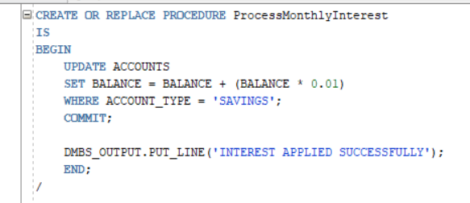
Output –
Interest Applied Successfully

Scenario 2: UpdateEmployeeBonus
Parameters:
- Department
- Bonus Percentage
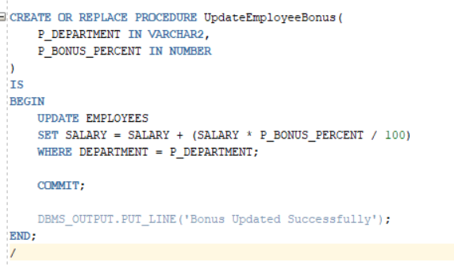
Output –
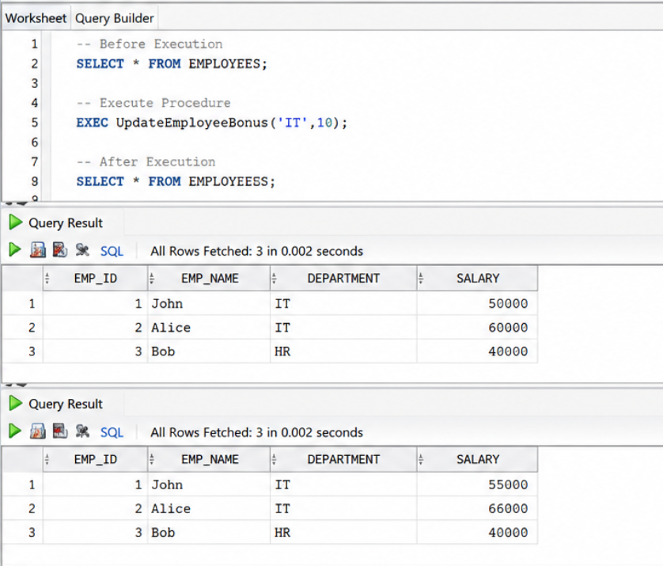

Scenario 3: TransferFunds
CREATE OR REPLACE PROCEDURE TransferFunds(
P_FROM_ACC IN NUMBER,
P_TO_ACC IN NUMBER,
P_AMOUNT IN NUMBER
)
IS
V_BALANCE NUMBER;
BEGIN

SELECT BALANCE
INTO V_BALANCE
FROM ACCOUNTS
WHERE ACCOUNT_ID = P_FROM_ACC;

IF V_BALANCE >= P_AMOUNT THEN

UPDATE ACCOUNTS
SET BALANCE = BALANCE - P_AMOUNT
WHERE ACCOUNT_ID = P_FROM_ACC;

UPDATE ACCOUNTS
SET BALANCE = BALANCE + P_AMOUNT
WHERE ACCOUNT_ID = P_TO_ACC;

COMMIT;

DBMS_OUTPUT.PUT_LINE('Transfer Successful');

ELSE
DBMS_OUTPUT.PUT_LINE('Insufficient Balance');
END IF;

EXCEPTION
WHEN NO_DATA_FOUND THEN
DBMS_OUTPUT.PUT_LINE('Account Not Found');
END;
/
